**1.**

# This program prompts the user to input length and width of a piece

# of paper in millimeters. It then displays the perimeter length of

# that paper in millimeters.

# Written By: Sam Graham, Tampa, FL, USA

# Written On: 1/26/2019

lengthInMM = input("In millimeters, how long is your piece of paper? ")

widthInMM = input("In millimeters, how wide your piece of paper? ")

paperPerimeter = (int(lengthInMM) * 2) + (int(widthInMM) * 2)

print("The perimeter of your paper is %d millimeters" % paperPerimeter)

**Output:**

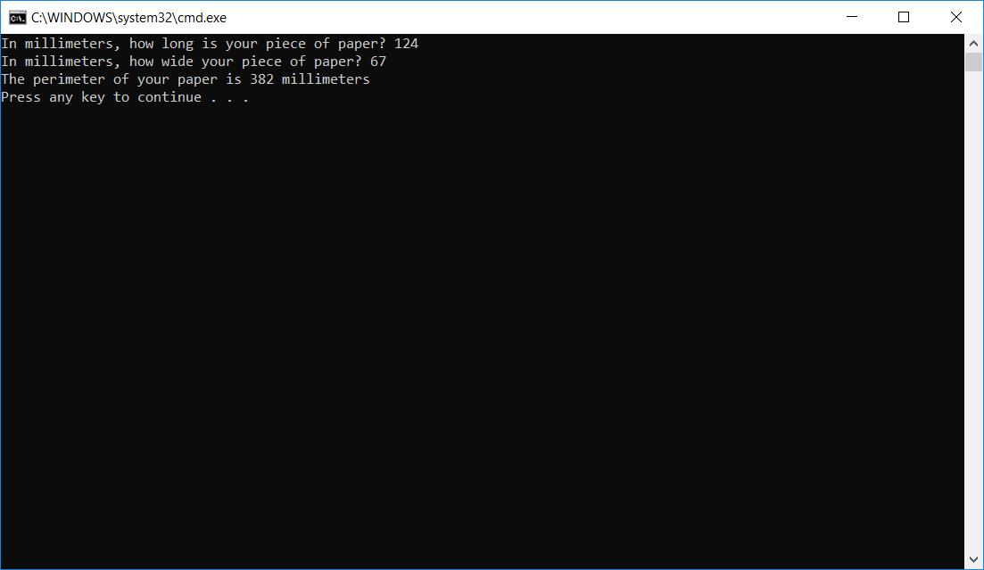

**2.**

# This program prompts the user to input the number of meters they would like

# converted. It then prints message that converts the input to feet and

# yards.

# Written by: Sam Graham, Tampa, FL, USA

# Written On: 1/26/2019

METERS_TO_FEET = 3.28

METERS_TO_YARDS = 1.094

print("This program converts meters to feet and yards.")

inputMetersAsString = input("How many meters would you like converted? ")

inputMetersAsFloat = float(inputMetersAsString)

print("%.3f meters is %.3f feet, which comes to %.3f yards"

% (inputMetersAsFloat, (inputMetersAsFloat * METERS_TO_FEET),

(inputMetersAsFloat * METERS_TO_YARDS)))

**Output:**

